Emergency Response Plan – Kestrel Ridge Wind Farm
Hannah Weber · 03 November 2025 · KR-HSE-ERP-0001

1. Site information for emergency services
Item | Details
Address / access | Kestrel Ridge Wind Farm, access from the B-road at Netherhall, locked gate (code from control room)
Grid reference of gate | given in the site emergency card at the gate and in the control room
Nearest A&E | Borders General Hospital, Melrose – approx. 40 minutes by road
Helicopter landing | Hard standing at T-09 crane pad (marked)
Turbine numbering | T-01 to T-18, number on each tower door and on the access track signs

2. Scenarios
Scenario | Response
Injury in nacelle or hub | Colleague starts first aid; rescue with nacelle rescue kit; call 999 and control room; meet ambulance at gate
Turbine fire | Evacuate, 500 m exclusion zone, call 999, control room isolates the turbine and the 33 kV feeder
Fire at substation | Evacuate, call 999, control room requests NordGrid Transmission to isolate the 132 kV connection
Oil spill | Contain with spill kit, prevent entry into drains and burns, inform site manager
Ice fall / ice throw | Leave hazard zone (342 m), keep public away, follow the ice throw procedure
Missing person / working alone | Control room calls after 60 min without check-in; site manager searches; call 999 after 30 min
Wildfire on moorland | Evacuate tracks upwind, call 999, inform landowners

3. Equipment
- Rescue kit (descender, rope, stretcher) in each nacelle; inspected every 12 months.
- First aid kit and AED in the site office and in each Highline van.
- Spill kits at the substation, in the site office and in each service vehicle.
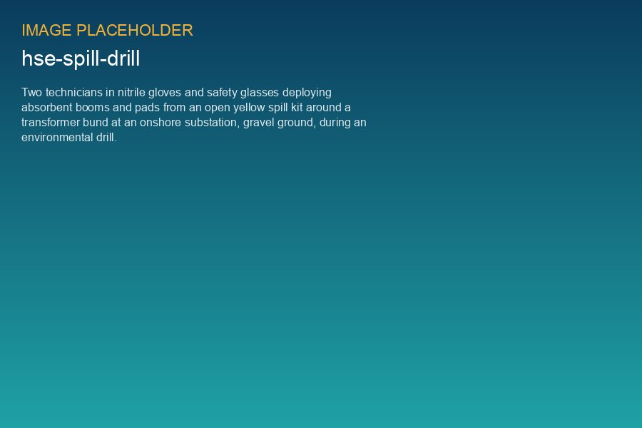
Spill drill at the Kestrel Ridge substation, October 2025

4. Drills
Nacelle rescue drill twice a year (April and October); fire evacuation drill annually; spill drill annually. Last nacelle rescue drill: 14 October 2025 – descent time from nacelle to ground 4 min 50 s.

